**ASSIGNMENT 3**

**Name:** Ravulapalli Madhavi

**Email**: madhaviravulapalli14@gmail.com

**Roll No:** 20NN1A0543

**College Name:** Vignan’s Nirula Institute of Technolofy and Science For Women

**Title:** A simple RESTFUL API using React.js, Creation of DataBase and Index.

**RestFul API code**

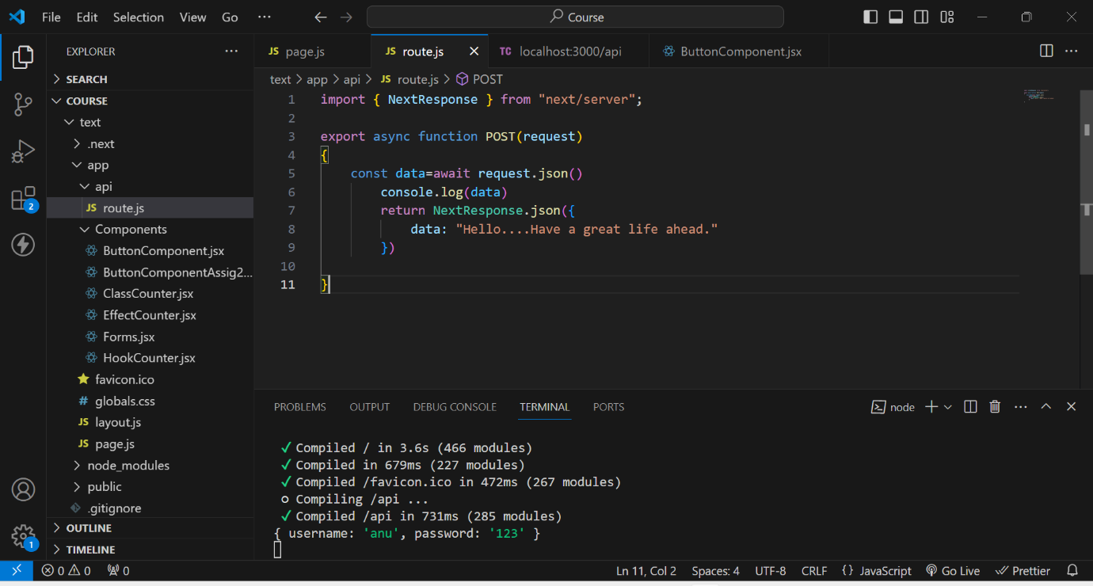

**Rest Output on ThunderClient**

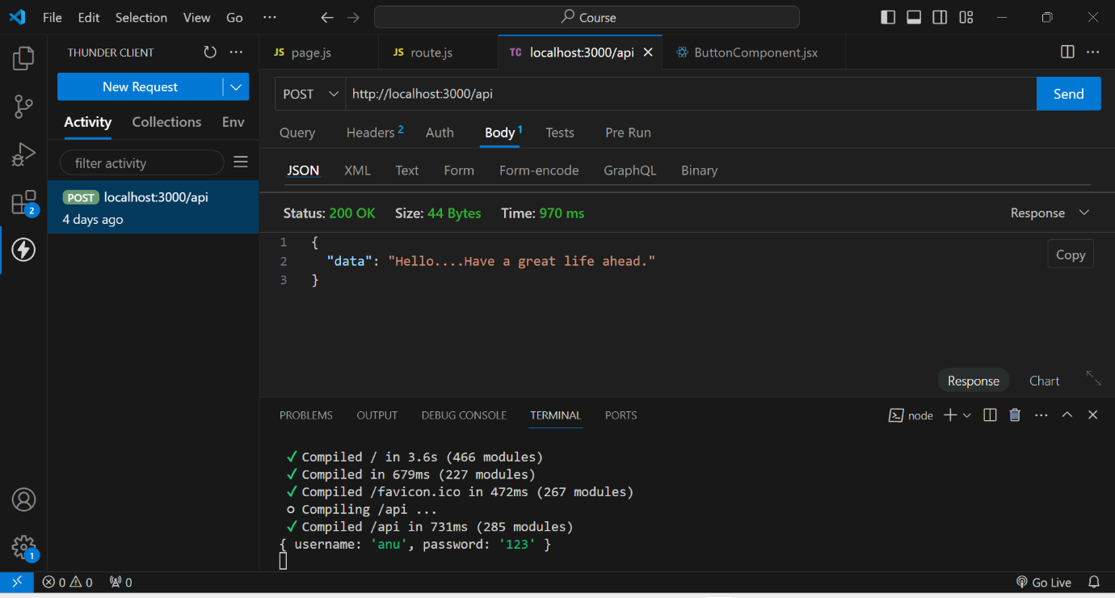This is the output when we create an API using REST.

**DataBase Creation**

1st we created a database named test

In that test we created a collection named Students

And finally by using ADD DATA , we added data of the students like rno, name, age.

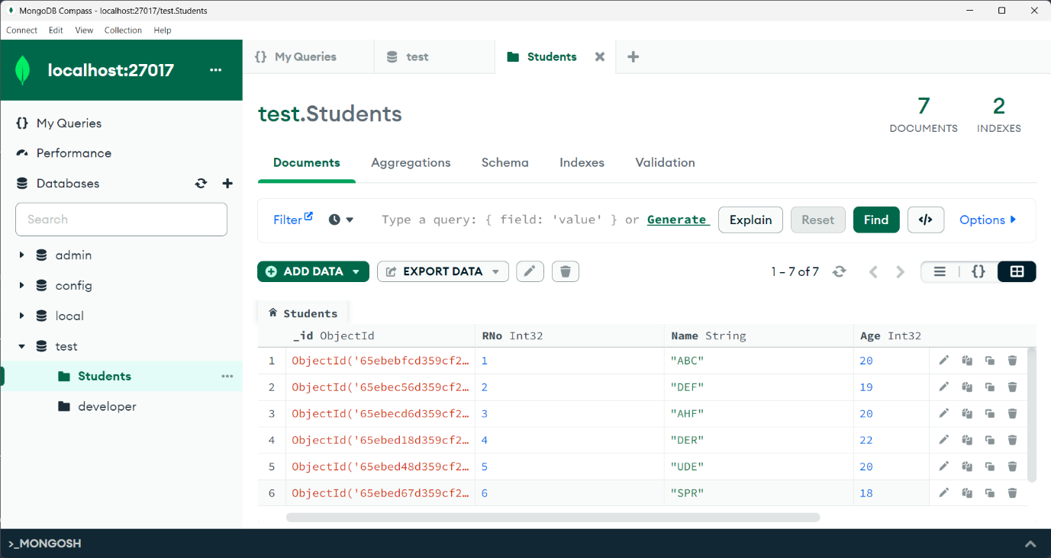

**Indexing Creation**

As rno is the unique attribute throug which we identify a student uniquely. So, here I created an index based on Rno. And assigned unique key to it.

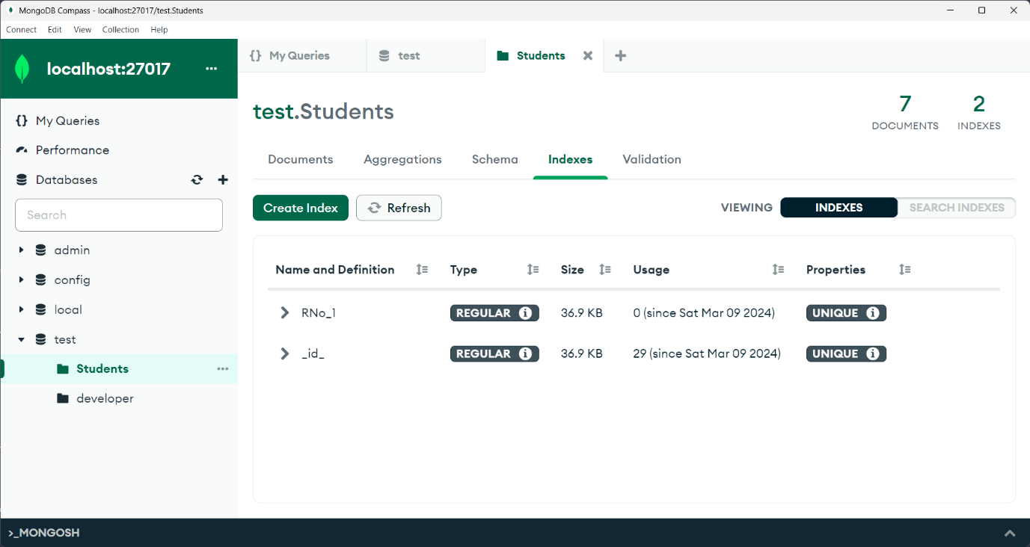

**Indexing usage**

As we gave Rno as unique, If we try to insert a duplicate document that is existed it shows an error like..duplicate collection.

